CIDM Rare Bird Submission Criteria – July 2015
Huawei Integrated Single Sourcing

Efficiency – The best practice provides documentation and/or metrics that explain how the manager increased productivity, lowered costs, or offered other improvements for his/her company. This efficiency would be a best practice for most companies. Most publications managers would recognize the results as excellent forms of process improvement, content management, minimalism, customer focus, or outsourcing, and so on.

Criteria Response – Huawei is a global leader of ICT solutions. Huawei’s telecom network equipment, IT products and solutions, and smart devices are used in 170 countries and regions. Huawei ranked 285th on the Global Fortune 500 based on its revenue in 2013. In 2014, the company’s revenue reached approximately USD 46.5 billion.
Huawei invest over 10% of our annual sales revenue into R&D and more than 45% of 170,000 employees engage in R&D. Huawei’s technical documentation plays an important role in helping Huawei’s business development. Delivering quality documentation in such a big business is challenging for huawei doc engineers. There are pain points with regard to Documentation efficiency, Quality, Time to Market.

Huawei's Integrated Single Sourcing allows for systematic reuse instead of ad-hoc and opportunistic reuse. The combination of single sourcing process and the Information Development Platform (IDP) maximizes collaboration between Huawei's different business units and employee roles. It also optimizes reuse, allowing not only technical writers but also other roles such as MKT, SEs, and product developers to reuse content to output the deliverables required by the IPD process. All the roles involved in the product development lifecycle act as both contributors and beneficiaries of single sourcing.

The Integrated Single Sourcing provides a comprehensive, end-to-end solution ensuring development efficiency, documentation accuracy, consistency and on-time delivery by taking advantage of proven technical communication methodologies such as User task analysis (UTA), minimalism, ATL, modular design, structured authoring and automated information development.

A comprehensive set of metrics assess the performance of single sourcing. The metrics show that this project achieved amazing benefits. It is recognized by Huawei Corporate management for outstanding achievement and winner of multiple awards, including the "Best R&D Transformation Project" award, "Key Breakthrough in Transformation" award, and other documentation system awards.

Efficiency:
- The IDP platform now manages 1.7 million topics which are generated by more than 17,000 MKT, system engineers, product developers, and technical writers. By reusing these topics, over 2730 million words have been published by the IDP platform.
- 70% of feature documentation is sourced from design documents. 100% of reference documentation, such as Alarm Reference, Error Code Reference, API Reference, Counter Reference, Command Reference, MIB Reference, Version Description, are now automatically sourced from the software development environment. A product from the Carrier Software Business Unit had 81% of its content automatically derived from the software development environment. The Annotated Task List (ATL) approach is used to normalize topics. This reduces information load dramatically and alleviates the burden of developing and maintaining redundant content. For example, the number of topics in a wireless MBTS product was reduced from 2894 to 1214, a 42% drop.
- Metrics show that generally an additional 10% investment in single sourcing design increases information development efficiency by 30% to 50% while also eliminating inaccuracy and inconsistency issues.
- Efficiency improvement is also evident from the following data: From 2011 to 2014, Huawei’s sales revenue increased from US$ 32.4 billion to US$ 46.5 billion, a 143% increase. During this period, the number of Huawei documentation personnel decreased from xxxx to xxx, a 26% decrease.

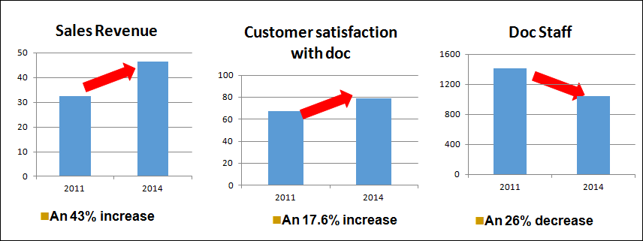

Accuracy and consistency:
- Huawei Integrated Single Sourcing greatly guarantees documentation accuracy and consistency. With the single sourcing process and the IDP platform, Reference documentation are now automatically sourced from the software development environment and Feature documentation from design documents. These contents in documentation could be simultaneously and automatically updated along with the ongoing product updates.
- Topics are reused between the different business domains, product families, product versions, pre-sale and after-sale documents, and document types, thus ensuring consistency among documents.

Time to market:
- The integrated single sourcing change the way the documentation is developed. The release of draft documentation is now possible at TR3 phase rather than TR6 phase in traditional way. Take Huawei wireless product as an example, the release of draft feature documentation is now 20 weeks in advance of product delivery, so customers can refer to the draft documentation when planning their network configuration.

Customer Focus – The best practice features improved methods or processes to incorporate customer needs in the information development process. There is clear evidence that customer input was used in the early design and development stages.

Criteria Response –Delivering quality documentation in such a big business is challenging for huawei doc engineers. There are some pain points as below:
- Siloed documentation development: Different business units (MKT, R&D, Documentation) develop the same or similar content during the product life-cycle resulting in duplicate content and inefficient use of resources.
- Documentation inability to keep up with product updates: These inaccuracies mislead customers or even cause network incidents.
- Frequent customer complaints arising from inconsistent content from Accounting, MKT and after-sale customer documentation.
- Confirming and verifying product data is too time-consuming: Product data such as technical specifications, parameters, CLI commands, and power consumption are found in diversified and distributed subsystems and vary during different phases of product development. One of the main pain-points of technical writers is the huge amount of time spent confirming the accuracy of this data
- Failure to deliver draft documents prior to product release

The Integrated Single Sourcing provides a comprehensive, end-to-end solution ensuring development efficiency, documentation accuracy, consistency and on-time delivery by taking advantage of proven technical communication methodologies such as User task analysis (UTA), minimalism, ATL, modular design, structured authoring and automated information development.

Documentation usability is guaranteed by using the UTA output as the input for single sourcing design. Improved efficiency frees technical writers from the cumbersome task of repeatedly addressing documentation maintenance issues and allows them to allocate more time to interact with customers and finding new ways to meet and exceed their customer’s needs All these factors significantly enhanced Huawei’s Total Information Experience and increased customer satisfaction for technical documentation as shown in the table below.

Note: Each year Huawei will conduct a complete and in-depth customer satisfaction survey by partnering with the global-leading agent in Customer Experience Management (CEM) solutions. There is an item about technical documentation: “Ability to Perform the Daily Operation and Maintenance Activities according to the Product Manuals”. The result of annual customer satisfaction survey is the most important KPI for documentation depts.

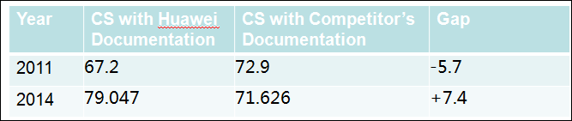

Transferability – The processes shown in this best practice could be transferred directly or with some modifications to other publications organizations. If adopted, the work has a high probability of offering similar improvements at the transfer site.

Criteria Response – The process used to implement Integrated Single Sourcing is well-defined and transferrable to other publications organizations.

Introduction to the Integrated Single sourcing process:
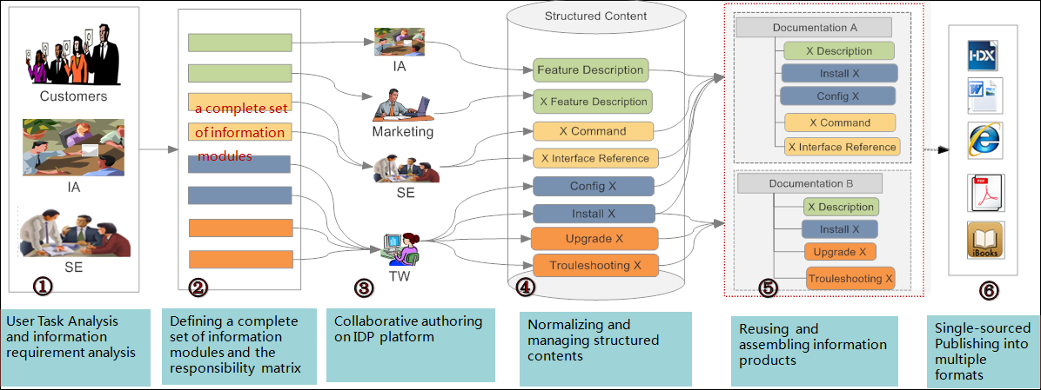

- User Task Analysis (UTA) and information requirement analysis: The IAs collaborate with system engineers (SEs) to create user roles and task models using the UTA and Minimalism approach, and then analyze the information requirements for each user role to fulfill a task. This method fully aligns documentation development with real user needs without missing critical information or retaining unnecessary information.
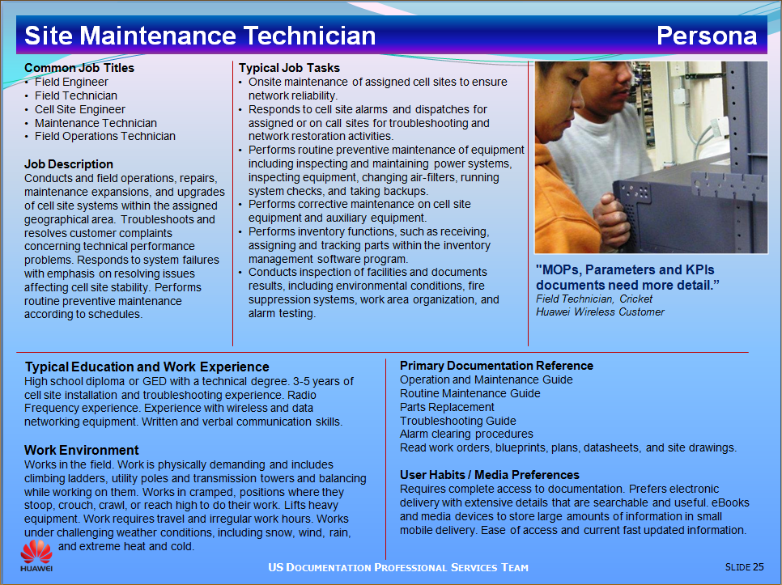

- With the output of UTA as the input, the IAs then define a complete set of information modules and the responsibility matrix. The responsibility matrix is a matrix showing responsible roles and the corresponding phases during which these information modules need to be developed according to Huawei’s Integrated Product Development (IPD) process.
- As per the responsibility matrix, the content for the information modules is generated by different business units as required by Huawei’s IPD process. For example:
- User requirement analysis is generated by MKT personnel via their Requirement Management platform.
- Feature & function design specifications are generated by SEs via their Design platform.
- Writing guidelines and examples are provided by the documentation department to help reuse content.
- Huawei’s Information Development Platform (IDP) can automatically capture the structured content from these platforms based on its single sourcing design. Also, IDP can be an embedded XML editor of these platforms so that different roles such as MKT, SE, product developers and technical writers collaborate and author the content. All the contents are stored in the Huawei CMS. For optimum reuse, the Annotated Task List (ATL) approach is used. The ATL normalizes similar or same information modules from different sources into a single module. Rules are set to regulate the use of Metadata in denoting information module attributes, including applicable products, versions, features, target users, and application scenarios.

- The IAs define the information products and the reuse relation table. The reuse relation table shows the reuse of topics between the different business domains, product families, product versions, and document types.
- Using the IDP platform, topics are flexibly reused and dynamically published into diversified deliverables.

To optimize collaboration and make single sourcing transferrable to multiple business units, the project team developed a complete set of guidelines and specifications:
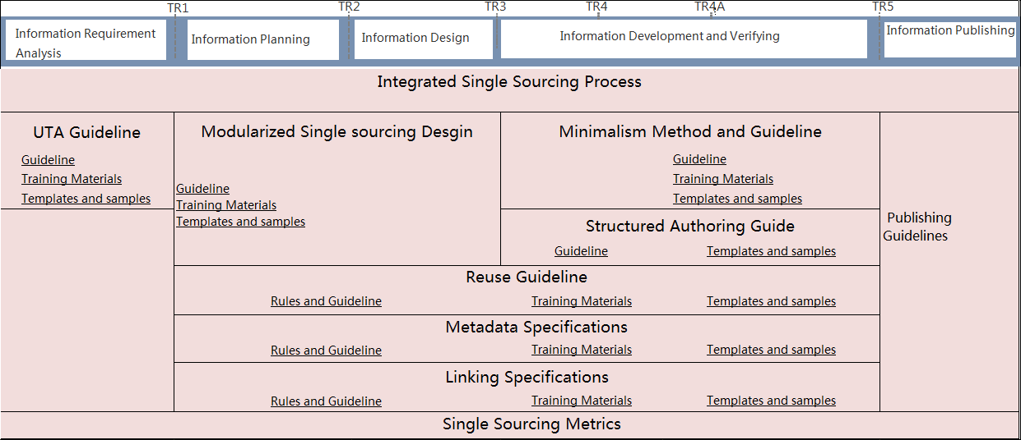

Innovation – The best practice offers unique approaches to traditional elements of information management, new processes, methods, or technologies that facilitate improvements in the way information management groups work within their company, with customers, or in the delivery of their products. The innovation should be measurable in business terms, such as reduced customer support calls, faster time to market, increased technical accuracy, easy access to concise information, and so on.

Criteria Response – The Integrated Single Sourcing provides a comprehensive, end-to-end solution ensuring development efficiency, documentation accuracy, consistency and on-time delivery by taking advantage of proven technical communication methodologies such as User task analysis (UTA), minimalism, ATL, modular design, structured authoring and automated information development. A comprehensive set of metrics assess the performance of single sourcing.

Huawei's Integrated Single Sourcing allows for systematic reuse instead of ad-hoc and opportunistic reuse. The combination of single sourcing process and the Information Development Platform (IDP) maximizes collaboration between Huawei's different business units and employee roles. It also optimizes reuse, allowing not only technical writers but also other roles such as MKT, SEs, and product developers to reuse content to output the deliverables required by the IPD process. All the roles involved in the product development lifecycle act as both contributors and beneficiaries of single sourcing.

Huawei’s Information Development Platform (IDP) can automatically capture the structured content from platforms such as Requirement Management Platform, Design Platform. Also, IDP can be an embedded XML editor of these platforms so that different roles such as MKT, SE, product developers and technical writers collaborate and author the content.

For optimum reuse, the Annotated Task List (ATL) approach is used. The ATL normalizes similar or same information modules from different sources into a single module. Rules are set to regulate the use of Metadata in denoting information module attributes, including applicable products, versions, features, target users, and application scenarios.

Introduction to Integrated Single sourcing IT & Tool Platform
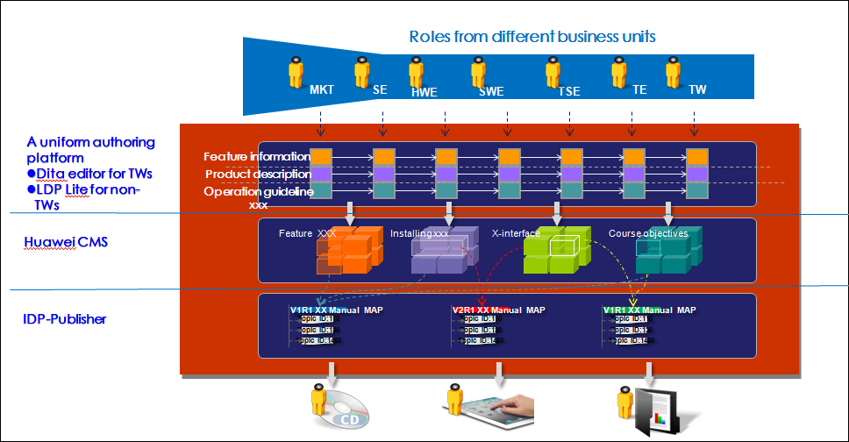

Transformational Value – The best practice is an example of creative thinking that takes information management to a higher level. Comments from company management or management peers about the change value of the effort would document its transformational value.

Criteria Response –Huawei invest over 10% of our annual sales revenue into R&D and more than 45% of 170,000 employees engage in R&D. Huawei’s technical documentation plays an important role in helping Huawei’s business development. Delivering quality documentation in such a big business is challenging for huawei doc engineers.

Huawei Integrated Single Sourcing is a big project led by the Corporate Documentation Dept from 2011 to 2015. It is listed as a top R&D transformation project and sponsored by high level management: Hao Jiankang, Chief Quality & Operations Officer and Xie Gengui, Director of Architecture and Key DFX Dept.

A diversity of roles such as MKT, system engineers, product engineers, information architects, and technical writers are involved in this project.

This project is recognized by Huawei Corporate management for outstanding achievement and winner of multiple awards, including the "Best R&D Transformation Project" award, "Key Breakthrough in Transformation" award, and other documentation system awards.

Leadership – The best practice subject matter, process, or results require outstanding leadership from the publications manager or team. For example, the manager or team changed the way work was done in the past, reallocated resources, reorganized for better results, solicited upper management support to bring in a content management system, teamed with customer support for better customer experiences, managed a corporate initiative, and so on.

Criteria Response – The Huawei Integrated Single Sourcing project achieved amazing results and showed outstanding leadership:
- Led by the Corporate Documentation Dept from 2011 to 2014.
- Listed as a top R&D transformation project
- Sponsored by high level management: Hao Jiankang, Chief Quality & Operations Officer and Xie Gengui, Director of Architecture and Key DFX Dept
- Collaborated with a diversity of roles such as MKT, system engineers, product engineers, information architects, and technical writers.
- Consulted with industry experts such as JoAnn Hackos from Comtech Services, Ann Rockley from The Rockley Group and other North American documentation experts.
- Transformation supported by four sub-projects: single-sourcing architecture design, single sourcing process & guidelines, single sourcing IT & tools, and pilot & implementation.
- Followed a well-defined project management process which included regular status checks and reporting to executives and management committees at regular, predefined milestones as shown in the figure below.
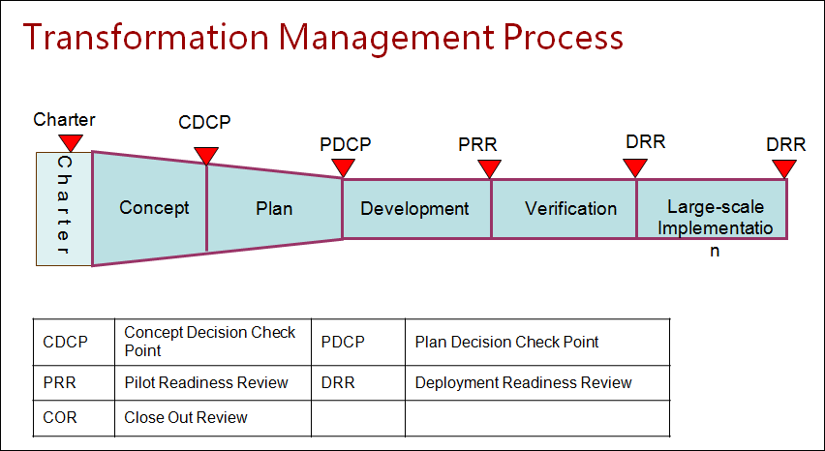
- Recognized by Huawei Corporate management for outstanding achievement and winner of multiple awards, including the "Best R&D Transformation Project" award, "Key Breakthrough in Transformation" award, and other documentation system awards.

Wang Xu Dong (Jackie)
Director, Huawei Information Architecture Department
Phone: +86-0755-28975710
Mobile: +86-13823519179
Email: jackie.wangxudong@huawei.com
Bantian, Longgang District,Shenzhen 518129, P.R.China

